AM000-Asia-China-Han-TLV-Eight Boss-Immortal and Spirits of the Four Directions

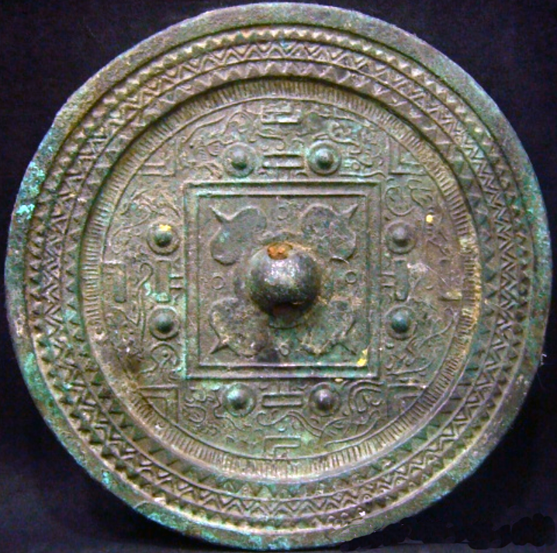

W. Han dynasty (206 BCE-8CE), 2nd century BC-TLV-Immortal and Spirits of the Four Directions

The National Palace Museum (diameter 14.1 cm, rim ht. 0.4cm) example is nearly identical except for the rim border (Yuhai Guo 1996: pl. 38 and pp. 106-107. The eight figures circling the zone outside of the central square are curvilinear designs and although unidentifiable as naturalistic forms may signify constellations, which would be in keeping with the cosmological basis of the TLV design. The Carter Collection example (Weight, 511gm, dia., 14.2 cm., rim height 0.6 cm., knob height 1.2 cm.) is nearly identical except that it is gilt.

This design type has a time horizon of two centuries from the mid-W. Han (Zhōngguó qīngtóngqì 2005: pls 60-61) to the late-E. Han dynasties (Guangzhou 1981, I:, fig 210 no. 4, fig. 276 no. 5).

References:

# Chou, Ju-Hsi. 2000. Circles of reflection : the Carter collection of Chinese bronze mirrors. Cleveland, Ohio : Cleveland Museum of Art,

# [Guangzhou Shi wen wu guan li wei yuan hui.](http://www.worldcat.org/search?q=au%3AGuangzhou+Shi+wen+wu+guan+li+wei+yuan+hui.&qt=hot_author); [Guangzhou bo wu guan.](http://www.worldcat.org/search?q=au%3AGuangzhou+bo+wu+guan.&qt=hot_author); [Zhongguo she hui ke xue yuan. Kao gu yan jiu suo.](http://www.worldcat.org/search?q=au%3AZhongguo+she+hui+ke+xue+yuan.+Kao+gu+yan+jiu+suo.&qt=hot_author) [Guangzhou City Heritage **Commission**, **Guangzhou** **City Museum**, **Institute of Archaeology** **eds.]** 1981. 廣州漢墓 / Guangzhou Han mu. [**Guangzhou Han Tombs]**. Beijing: Cultural Relics Publishing House 1981. 2 v.

Yuhai Guo. 1996. Gu gong cang jing. 故宮藏镜 [Mirrors in the National Palace Museum]. Beijing : Zi jin cheng chu ban she [Forbidden City Publishing House,].

Zhōngguó qīngtóngqì quánjí biānjí wěiyuánhuì biān 中国青铜器全集编辑委员会编 .[Editorial Board of The Complete Works of Chinese bronzes] 2005. 中国青铜器全集.16，铜镜 [Complete Works of Chinese Bronze, v. 16, Bronze mirrors] 文物出版社文物出版社 : 新华书店北京发行所发行, Beijing: Wen wu chu ban she [Cultural Relics Publishing House].